Part A 小作文 信件
Suppose you won a translation contest and your friend Jack wrote an email to congratulate you, and ask advice on translation. Write him a reply to
1)thank him;
2)give your advice.
You should write neatly on the ANWSER SHEET. Do not sign you own name at the end of the letter, use “Li Ming ” instead. Do not write the address .(10 point)

May 5th , 2013.
Dear Jack
I’m Liming.____Thank you for your E-mail last week to congratulate me on my winning the translation contest. I'm writing this letter to share some of my advice on translation in response to your question in the previous letter.
For me, translation is the ability to interpret the meaning of the original language and convert it into another language. To make a decent translation,as mentioned by Yanfu---a Chinese translating expert, there are two major points you need to follow. First, be loyal to the original writing content, which means you should not change anything about the original meaning, as your modification of the text could stray from the authors'. When translating, another crucial aspect you need to pay attention to is expressiveness, which means that your expression in the target language needs to be understandable. Being stubborn with the grammar rules may result in unreadable language, which you must avoid.The last point you need to keep in mind is elegance. It literally means to choose proper vocabulary for a specific register, thus learning words of different formality level could be a great help.
Again, I'm very grateful for your congratulations on me. I hope my advice will be helpful for your translation.
Sincerely yours,
Jane Hart.

大作文 (pie chart)
48.Directions:
Write an essay based on the following chart. you should
1) interpret the chart and
2) give your comments.
You should write about 150 words on the ANSWER SHEET.(15 points).
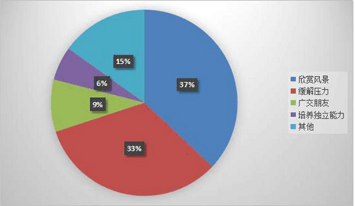
某高校大学生旅游目的调查

As is clearly demonstrated in the pie chart, the travel intentions of college students varied greatly in a certain university. Based on the diagram given, pupils who travel on the purpose of appreciating the scenery take a comparatively large share, accounting for 37%, followed by those who travel to relieve pressure, a proportion of 33%. By contrast, the percentage of students travelling aiming at making friends, fostering independent ability and other accounts for9%, 6% and 15% respectively.
There are at least two primary factors accounting for such phenomenon. Firstly, when traveling to the newly-visited places our horizon can be broadened, as practical experience can be a great supplement for our book knowledge. For example, after learning great poems of beautiful landscape, our appreciation can be enhanced by the impression of sight seeing on the spot. Meanwhile, due to the busy schedule of university life, college students, who are engaged in studying, dating and participating in other activities, are especially susceptible to omnipresent stress. Via touring, their long-standing pressure can be effectively reduced.
In view of the arguments above, we can safely draw a conclusion that with the ever-increasing material and cultural life, the number of university students touring will keep growing in the forthcoming decade.

小作文：回信
Section IV Writing
Part A
47. Directions:
Suppose you are invited by Professor Williams to give a presentation about Chinese culture to a group of international students. Write a reply to
1）Accept the invitation, and
2）Introduce the key points of your presentation.
You should write neatly on the ANWSER SHEET.
Do not sign you own name at the end of the letter, use “Li Ming ” instead.
Do not write the address .(10 points)

Dear Professor Williams,
My name is Li Ming and I am an international student from China. Thank you for your invitation to a presentation in the English corner for international students. I’m writing this letter to accept the invitation and inform you of my outline of the presentation. The following are the details.
First thing I want to deliver is_the traditional Chinese festival, such as Spring Festival and Mid-Autumn Festival, in which the activities and customs are full of Chinese culture. The second matter concerned is that the ancient poems, which are related to the festival, will be covered in my presentation. Finally, a discussion of differences between Chinese and other cultures will be held at the end of my presentation. I think this will provide us with an opportunity to interact and enhance our relationship.
Thank you for your time and invitation once again. Hopefully, the beauty of Chinese culture will be appreciated by my audience.
Sincerely yours,
Liming

48. Directions:
Write your essay on ANSWER SHEET. (15 points)
You should
1) interpret the chart, and
2) give your comments.
You should write about 150 words on the ANSWER SHEET. (15points)

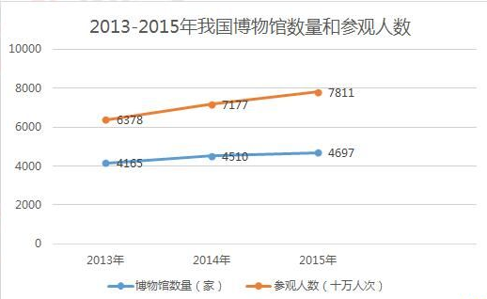

As is subtly mirrored in the line chart, the number of museums and visitors in China both surged at a different rate from 2013 to 2015. What the diagram conveys goes far beyond merely the growth of the museum industry. Instead, it reflected the ever-increasing cultural needs of Chinese citizens. Several factors weigh heavily for this boom, among which two major ones suspended on the top of the list which should never be overlooked.
Firstly, when visiting places full of knowledge and culture, our horizon can be broadened, as practical experience can be a great supplement for our book knowledge. For example, after learning great poems of beautiful cultural relics, our appreciation can be enhanced by the impression of sight seeing on the spot. Meanwhile, owing to the prosperity of the economy in China, the whole country promotes the policy of cultural confidence. As a consequence, ordinary residents are now able to get free admission to museums. A classic case in point is one of my classmates, who spends his free time visiting museums all around Beijing. Thus, from this standing point, there is nothing more beneficial and challenging than developing the nation’s cultural industry.
In view of the arguments above, we can safely draw a conclusion that with the ever-increasing material and cultural life, the number of university students touring will keep growing in the forthcoming decade.

Section ⅣWriting
Part A
47. Directions:
Suppose you have to cancel your travel plan and will not be able to visit professor Smith. write him an email to
1)apologize and explain the situation, and suggest a future meeting
2)You should write about 100 words on the ANSWER SHEET.
Do not use your own name. Use “Li Ming” instead.
Do not write your address.(10 points)

Dear Professor Smith,
I’m Li Ming, one of your students in college. I’m writing this letter to apologize to you. I was planning to travel to your city next month to pay you a visit. This plan, however, was canceled due to an inevitable reason.
First, I want to apologize for my schedule. My university was about to hold a thesis defence at the end of this month. Unexpectedly, the school postponed this event for a week. It changed my plan for the graduation trip, in which I would pay you a visit. At last, I want to take a rain check of our appointment. If it’s available for your schedule I would pay you a visit a week later.
Again, I'm sorry about this delay. Please let me know about your schedule. Sincerely yours,
Liming

Part B
48. Directions：Write an essay based on the chart below. In your writing you should
1)interpret the chart,and
2)give your comments
You should write about 150 words on the ANSWER SHEET.(15 points)

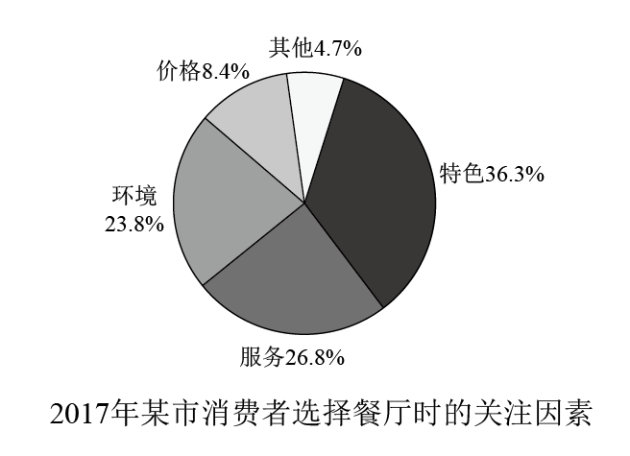
As is subtly mirrored in the pie chart, factors, which influenced consumer’s choices when going to the restaurants, varied a lot. Based on the diagram given, people who choose the restaurants with the preference of special features take a comparatively large share, accounting for 37%, followed by those who prefer the service, a proportion of 33%. By contrast, the percentage of consumers who put emphasis on environment, price and other accounts for 9%, 6% and 15% respectively.
Several factors weigh heavily for their choices, among which two major ones suspended on the top of the list which should never be overlooked. In the first place, eating at special restaurants and a comfortable environment offers customers a valuable experience. Based on a most recent study, a growing body of evidence showed that most restaurant eaters, who focus on the special features and environment, are satisfied with their choices. Meanwhile, owing to the prosperity of economy in China, the price is not a concern for the majority anymore. As a consequence, these newly-rich eaters will spend more time and energy trying restaurants with decent service.
In view of the arguments above, we can safely draw a conclusion that with the ever-increasing material and economic life, the number of university students touring will keep growing in the forthcoming decade.

Section ⅣWriting
Part A
- Directions:
  - Directions:
  - Suppose Professor Smith asked you to plan a debate on the theme of city traffic. Write him an email to suggest a specific topic with your reasons, and
  - tell him about your arrangements.
You should write about 100 words on the ANSWER SHETE. Do not use your own name. Use “Li Ming” instead(10 points)

Dear Professor Smith,
I’m Li Ming, one of your students in college. I’m writing this letter to inform you of my arrangements of the debate, which you asked me to plan last week. The theme is so intriguing that I propose a controversial topic that whether we should limit the number of private cars in the city.
First, the reason I want to hold the topic of debate is reality that there is a growing number of the private cars on the road with the rapid development of the economy. As a consequence, it’s getting increasingly jammed in the rush hours. The plan is that the debate will be held in the 7:00 P.M. next Saturday, in the classroom 7. All the students from the department will be required to attend as the audience.
Again, I'm sorry about this delay. Please let me know about your schedule.

Sincerely yours,
Liming

Part B
- Directions：Write an essay based on the chart below. In your writing, you should
  - interpret the chart,and
  - give your comments
You should write about 150 words on the ANSWER SHEET.(15 points)

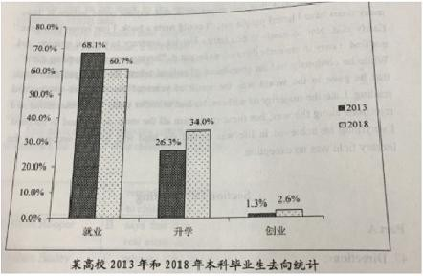
As is subtly mirrored in the column chart, the choices of university undergraduate upon graduation varied a lot from 2013 to 2018. What the diagram conveys goes far beyond merely changes upon graduation. Instead, it revealed the tendency for higher education. Compared to 2013, a growing number of students choose to seek higher education rather than get a job. Still, only a few of them opt to be entrepreneurs. (可写可不写)
Several factors weigh heavily for this tendency, among which two major ones suspended on the top of the list which should never be overlooked.（第一段第二段都可以） In the first place, owing to the prosperity of the economy in China, the whole country promotes the policy of higher education. （论点1）Based on a most recent study, a growing body of evidence showed that most successful social elites, who seek further education, admitted that this policy is helpful for them to get the scholarship, with which they can finish their education without financial difficulty. （论据1）Meanwhile, those with a diploma of master or even doctor degree are valued in the job market with the rapid development of society. 论点2 As a consequence,college students need to spend more time and energy in degrees than ever before.论据2 A classic case in point is one of my classmates, who goes to the postgraduate school. Thus, from this standing point, there is nothing more beneficial and challenging than advanced education__（锦上添花）__.(detrimental and harmful)
In view of the arguments above, we can safely draw a conclusion that with the ever-increasing demand of society and the encouragement of the country, the proportion of university students, who(which) seek higher education, will keep growing in the forthcoming decade.（总结预测）

Section IV Writing
Part A
47. Directions:
Suppose you are planning a tour of a historical site for a group of international students. Write an email to
1) tell them about the site, and
2) give them some tips for the tour
Please write your answer on the ANSWER SHEET .
Do not use your own name, use“Li Ming”instead. (10 points)

Dear international students,
I’m Li Ming, one of the students in the Student Union. I’m writing this letter to inform you of the touring plan for the historical site, which you learned about this semester in a lesson of Chinese culture. The site you are going to visit next Sunday is The Summer Palace, which is located next to our school. The following are some tips for you.
First, be sure to take the camera, with which you can take some memorial pictures of the imperial palace. If you are interested, you can do some research of the delicate collections of the antiques before your tour. Finally, it’s going to be a rainy day. Therefore, you need an umbrella for the outdoor walking tour.
I hope my suggestions would be of benefit for you. Please feel free to contact me. I am looking forward to your reply. Enjoy your tour!

Sincerely yours,
Liming

Part B
48. Directions:
Write an essay based on the chart below. In your writing, you should
1) interpret the chart, and
2) give your comments.
You should write about 150 words on the ANSWER SHEET. (15 points)
2%
17%
20.5%
59.5%
某高校学生使用手机阅读目的

As is subtly mirrored in the pie chart, purpose of students, who use smart phone to read, varied a lot in a certain college. Based on the diagram given, students who choose to read on the purpose of studying take a comparatively large share, accounting for 59%, followed by those who aim at killing time, a proportion of 20.5%. By contrast, the percentage of students who put emphasis on information, and other accounts for 17% and 2% respectively.
Several factors weigh heavily for this difference of students’ purposes, among which two major ones suspended on the top of the list which should never be overlooked. In the first place, due to the busy schedule of university life, college students, who are engaged in studying, must find it helpful for them to improve efficiency when reading on the smart phone. Based on a most recent study, a growing body of evidence showed that most successful social elites, who use the smart phone to study, admitted the convenience of the E-book. Meanwhile, owing to the prosperity of economy in China, the price of the phone is not a concern for the majority anymore. As a consequence, these phone users in the college will spend more time and energy on the small device in their spare time.
In view of the arguments above, we can safely draw a conclusion that with the ever-increasing material and cultural life, the number of university students, who use smart phone to read, will keep growing in the forthcoming decade. If we try our utmost to use it reasonably and avoid overindulgence, our future will be promising and rosy.

Section IV Writing
47. Directions: Suppose your class is to hold a charity sale for kids in need of help. Write your classmates an email to
1) inform them about the details, and
2) encourage them to participate.
You should write about 100 words on the ANSWER SHEET.
Do not use your own name; use “Li Ming” instead.
Do not write your address. (10 points)

Dear classmates,
I’m Li Ming. I’m writing this letter to inform you of detail of the charity sale, which we discussed last week at the class meeting. As we planned before, the sale,for kids in need, will be held next Sunday in the evening. There are three parts in the sale.
First, the principal will be invited to deliver a speech about the purpose and the necessity of this charity sale. Then comes the most interesting part of the night, the song performance, in which most of teachers in our school will join us. At last, some of the books and goods will be sold at a reasonable price. I believe you will participate in this generous and meaningful event.
Thank you for your kindness.

Sincerely yours,
Liming

48. Directions: Write an essay based on the following chart. In your writing, you should
1) interpret the chart, and
2) give your comments.
You should write about 150 words on the ANSWER SHEET. (15 points)
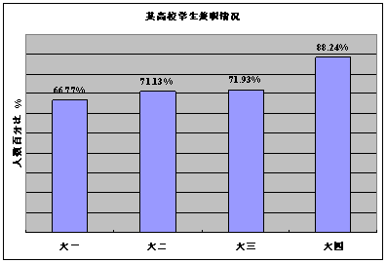

As is subtly mirrored in the column, from freshman to graduate year, the proportion of college students who participated in the part time job, increased dramatically. What the diagram conveys goes far beyond merely changes in the part time job of college students. Instead, it reflected the ever-increasing needs of practical experience in the job market.
Several factors weigh heavily for the phenomenon, among which two major ones suspended on the top of the list which should never be overlooked. In the first place, when doing a part time job, which is related to our major, our horizon can be broadened, as practical experience can be a great supplement for our book knowledge. Based on a most recent study, a growing body of evidence showed that most successful social elites, who did part time jobs during college, admitted that the experience is helpful. Meanwhile, owing to the prosperity of the economy in China, the whole country needs more labour with expertise. As a consequence, college students have become popular in the job market. A classic case in point is one of my classmates, who jumps on the bandwagon of the part time job and finds his expertise necessary for the job. Thus, from this standing point, there is nothing more beneficial and challenging than the part time job.
In view of the arguments above, we can safely draw a conclusion that with the ever-increasing material and cultural life, the number of university students, who do the part time job during university life will keep growing in the forthcoming decade. If we try our utmost to balance it and avoid overindulgence, our future will be promising and rosy.

Section IV Writing
Part A
47. Directions:
Suppose you are going to study abroad and share an apartment with John, a local student. Write him to email to
1) tell him about your living habits, and
2) ask for advice about living there.
You should write about 100 words on the ANSWER SHEET.
Do not use your own name. Use “Li Ming” instead.
Do not write your address. (10 points)

Dear John,
I’m Li Ming, one of the students from China. I’m going to be your roommate next semester. I think it’s friendly to write a letter before we formally meet, therefore I’m writing this letter to share with you some of my living habits so that we can share the room and get along friendly and harmoniously.
First, I’m an early sleeper. Usually, I go to sleep before 10 o’clock. I hope you like to go to bed early too, as it’s a healthy habit to get enough rest. Besides, I’m a non-smoker. However, I don’t mind if you smoke in the room. Sometimes I like to do some leisure activities in the dorm, such as playing games and watching football games. It will be a lot of fun if we can do that together.
At last, I want to ask you for some advice about living conditions there. Please feel free to contact me. I am looking forward to your reply.

Sincerely yours,
Liming

Part B
48. Directions:
Write an essay based on the following chart. In your writing, You should
1) interpret the chart, and
2) give your comments.
You should write about 150 words on the ANSWER SHEET. (15points)
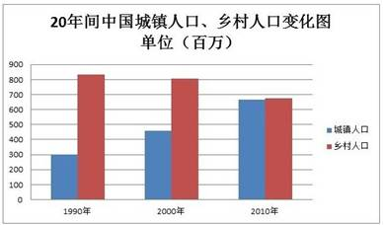

As is subtly mirrored in the column, from 1990 to 2010, the demography of rural areas decreased to an equal proportion of urban areas, which rocketed up during this period. What the diagram conveys goes far beyond merely changes in population structure. Instead, it reflected the ever-increasing needs of urbanization.
Several factors weigh heavily for the urbanization, among which two major ones suspended on the top of the list which should never be overlooked. In the first place, owing to the prosperity of the economy in China, the whole country promotes the policy of urbanization. Based on a most recent study, a growing body of evidence showed that most new citizens, who migrated from rural or outskirts, find this policy helpful. Meanwhile, living in the urban area provides us with a safer area both in life and career. As a consequence, more residents choose to spend time and energy to seek the opportunity of living in the city. A classic case in point is one of my classmates, whose hometown is a village. He settled in the city after graduation. Thus, from this standing point, there is nothing more beneficial and challenging than moving to the city.
In view of the arguments above, we can safely draw a conclusion that with the ever-increasing material and cultural life, the number of urban citizens will keep growing in the forthcoming decade.

Section IV Writing
Part A
47. Directions:
Suppose your university is going to host a summer camp for high school students. Write a notice to
1) briefly introduce the camp activities, and
2) call for volunteers.
You should write about 100 words on the ANSWER SHEET.
Do not use your name or the name of your university.
Do not write your address. (10 points)
Notice
November 11th, 2020
This notice is for the purpose of informing the students in the No.1 High school in Beijing of the summer camp, which is going to be held this summer holiday. The following details can account for this event.
First, all the students are required to attend these activities because it’s related to your field trip. In the summer camp, there will be practical lessons related to the chemistry you learned in school. During the 7 days, you will be required to work on a project, in which a lot of teamwork are involved. A contest of chemistry experiment will be held at the end of the summer camp. Therefore, we need 20 students to be volunteers.
If you are interested or have any questions, feel free to contact me at 999918 in the working hours..

Student Union of Peking University

Part B
48. Directions:
Write an essay based on the following chart. In your writing, you should
1) interpret the chart, and
2) give your comments.
You should write about 150 words on the ANSWER SHEET. (15 points)
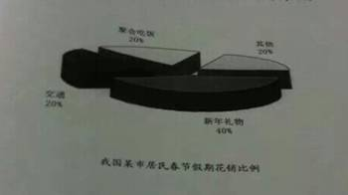
As is subtly mirrored in the pie chart, the money people spent during Spring Festivals in a certain city goes to different places. Based on the diagram given, new year presents take a comparatively large share, accounting for 40%, followed by transportation, parties and other, accounting for a proportion of 20% respectively.
Several factors weigh heavily for this large amount of money in gifts, among which two major ones suspended on the top of the list which should never be overlooked. In the first place, owing to the prosperity of the economy in China, the whole country promotes the policy of gift consumption. Based on a most recent study, a growing body of evidence showed that most citizens find it convenient to spend money during the festival. Meanwhile, emotional factors do play an important role in buying gifts. When purchasing gifts, which is most people’s choice, the positive emotion can be triggered. A classic case in point is one of my classmates, who buys people around him gifts every year. He seems to find pleasure within it.
In view of the arguments above, we can safely draw a conclusion that with the ever-increasing material and cultural life, the money we spend on gifts will keep growing in the forthcoming decade.

Section Ⅳ Writing
Part A
- Directions：
Suppose you are organizing an online meeting. Write an email to Jack, an international student, to
invite him to participate, and
tell him the details.
You should write about 100 words on the ANSWER SHEET.
Do not use your own name. Use “Li Ming” instead.
Do not write your address. (10 points)
Dear Jack,
I’m Li Ming, a student in the foreign language department. Recently, we’re holding a new semester meeting for international students in our department. Therefore, I’m writing this letter to invite you,with great respect, to participate in this online meeting.. You need to pay attention to the following details.
First and foremost, the meeting will be held at 5 P.M the day before the the new semester. You need to attend the meeting with a computer with access to the Internet. Besides, you need to open your Wechat 5 fifteen minutes before the meeting, because the teacher is going to initiate a group video chat code when the meeting begins. After the meeting, you need to submit your personal information related to the meeting.
Thank you for your time.

Yours,
Li Ming

- Directions：
Write an essay based on the chart below. In your writing, you should
- interpret the chart, and
- give your comments.
You should write about 150 words on the ANSWER SHEET. (15 points)

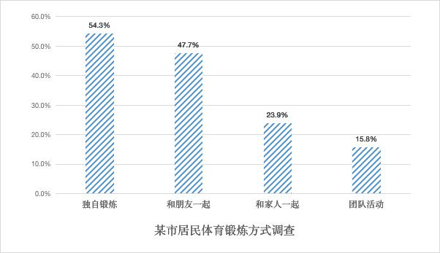
As is subtly mirrored in the column chart, ways, which residents of a certain city choose when working out, varied a lot. Based on the diagram given, people who choose to work out with the preference of being alone take a comparatively large share, accounting for 54.3%, followed by those who prefer the companionship of friends, a proportion of 47.7%. By contrast, the percentage of residents who put emphasis on family, or teamwork accounts for 23.9% and 15.8% respectively.
Several factors weigh heavily for this variety of working out choices, among which two major ones suspended on the top of the list which should never be overlooked. In the first place, due to the busy schedule of modern life, citizens, who are engaged in working or studying, must find it helpful for them to improve efficiency when working out alone without being disturbed. Based on a most recent study, a growing body of evidence showed that most successful social elites, who enjoy solitude when exercising, have admitted that being alone costs less time. Meanwhile, exercising with friends provides a safer environment for both your body and your health.
In view of the arguments above, we can safely draw a conclusion that with the ever-increasing material and cultural life, the variety of body building will keep growing in the forthcoming decade.

